Phishing attack and investigation

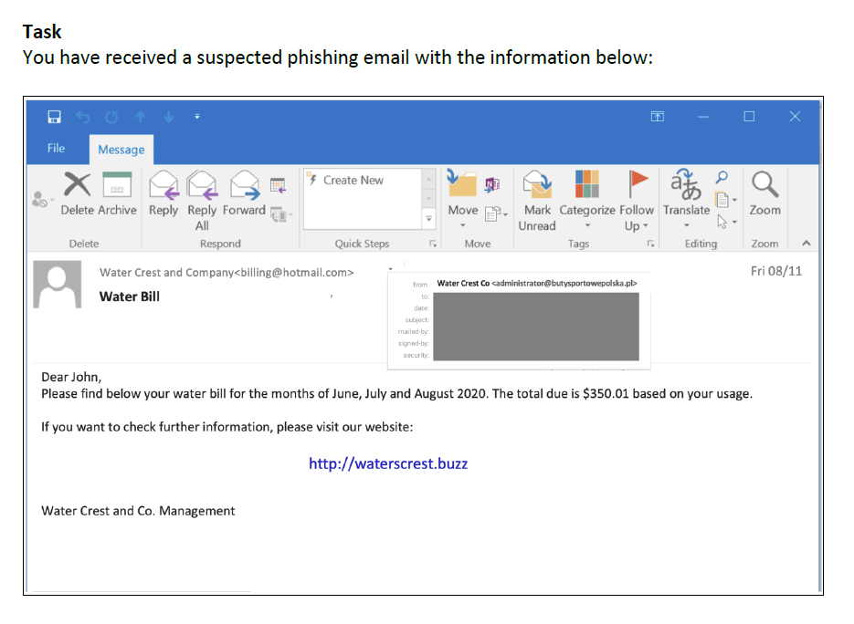

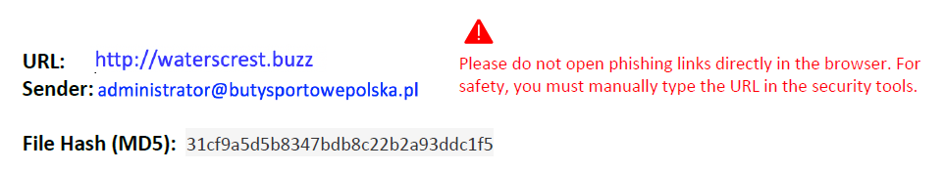

It is phishing email or not?

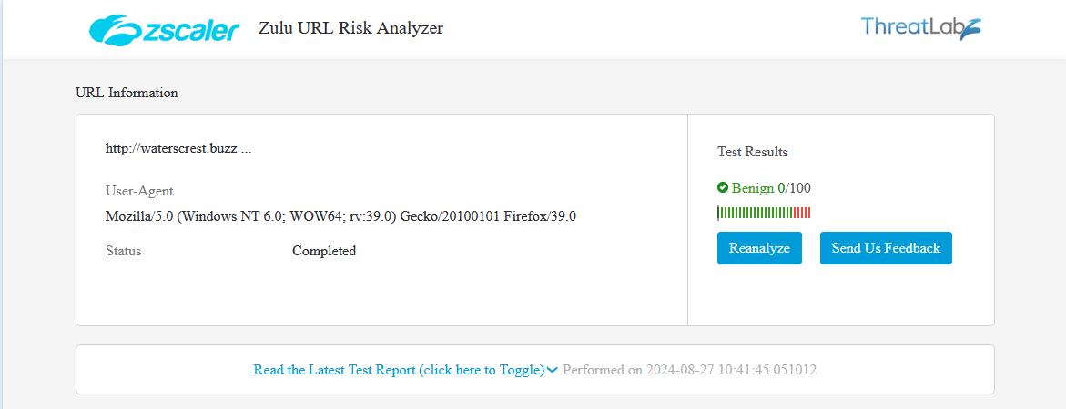

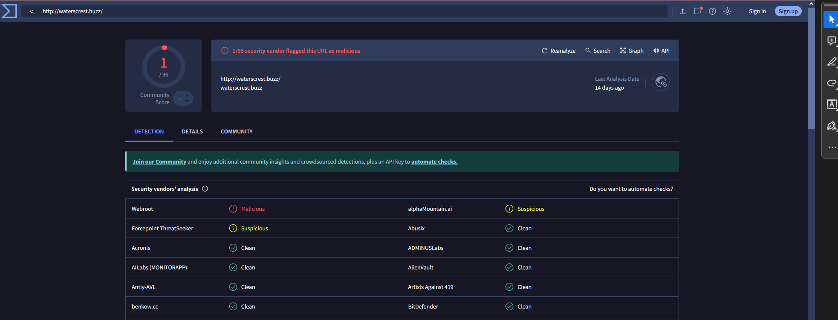

**Definitely Malicious**

Is the file malicious? (based on the given hash)

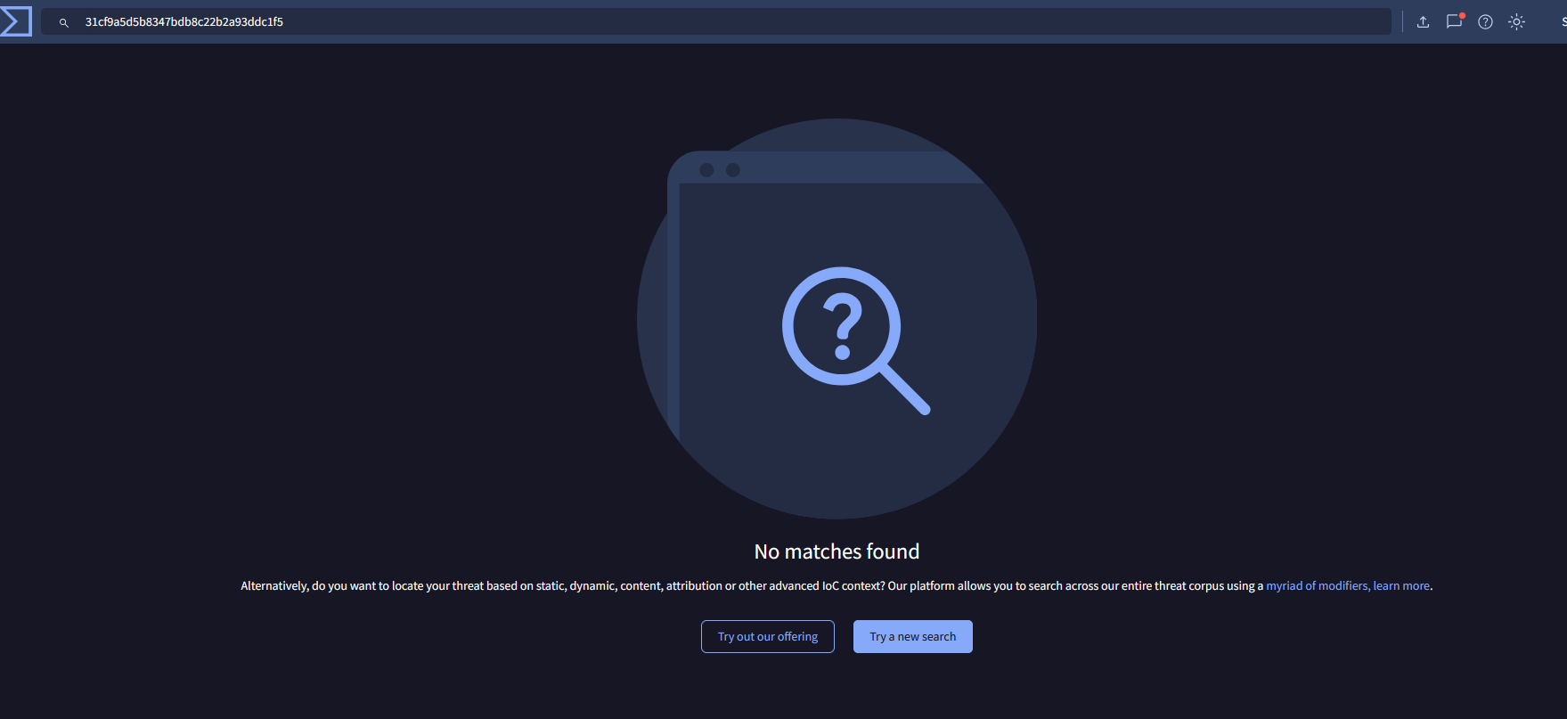

**No**

Is the sending domain reputable?

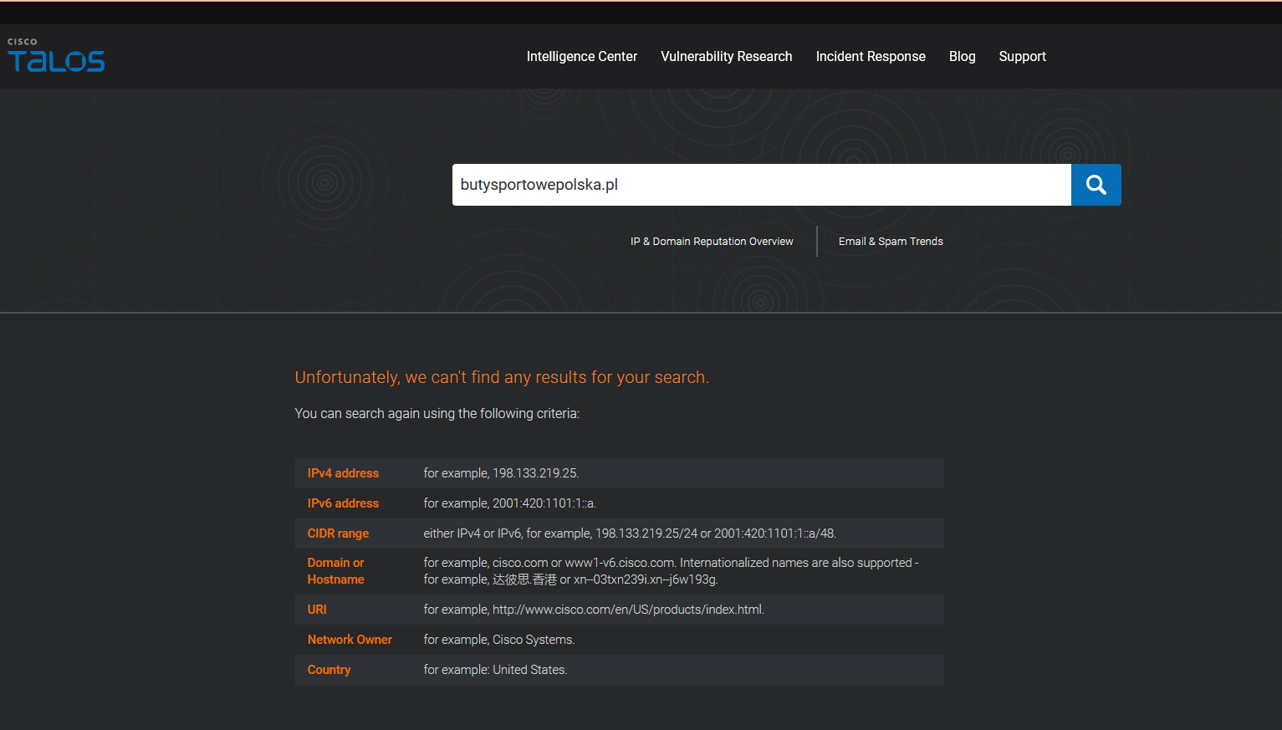

**Answer: Not flagged as malicious**

**\*The source may be changed or blocked**